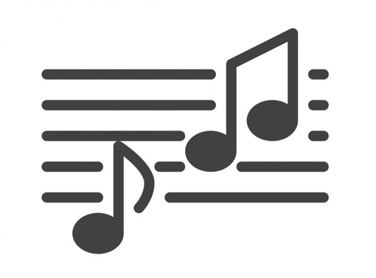
SANGMIX 2:

No! No! Yeees
When woman say "no" but she won't let you go
And you cannot make up what to guess
Statistics will show when woman don't let you go
That when woman say "no", she mean "yes"
If woman slap your face when you behave in bad taste
And she tell you that you are shameless
You'll know that if she still stay instead of runnin' away
That when woman say "no", she means "yes"
________________________________________________________________________________
»Op i høet med dig lille Trine
du ka råve å skri’e å hvine,
lisså møj som du vil
for når jæ kommer til,
er det mig der bestemmer,
hvordan det går til.«
________________________________________________________________________________Ja und Nein
(Ja og nej)
das kann das gleiche sein
(det kan være det samme)
Es kommt dabei nur darauf an
(Det kommer kun an på)
ob der Mann es dann fühlt oder nicht
(Om manden føler det eller ej) ________________________________________________________________________________
Girl I want to make you sweat
Sweat 'til you can't sweat no more.
And if you cry out I'm gonna push it some more.
Girl I want to make you sweat
Sweat 'til you can't sweat no more.
And if you cry out I'm gonna push it
Push it push it some more.

